Case Study-28*th* August 2023

By Nalin Bhargava

Nalin.bhargava@shell.com

The document is the submission of my case study for all the foundational skills learnt during the bootcamp.

**Problem Statement**

Implementing a Seamless CI/CD Workflow for a Spring Boot Application using Azure Boards, Azure, Git, Maven, Docker, Github, Github Actions.

**Project Management Setup**

Creating Epic

Step 1: Project Management Setup:

Creating stories and sprint and scrum on azure devops

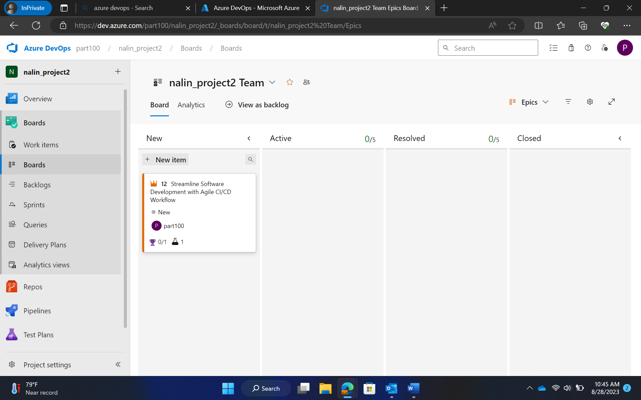

Epic

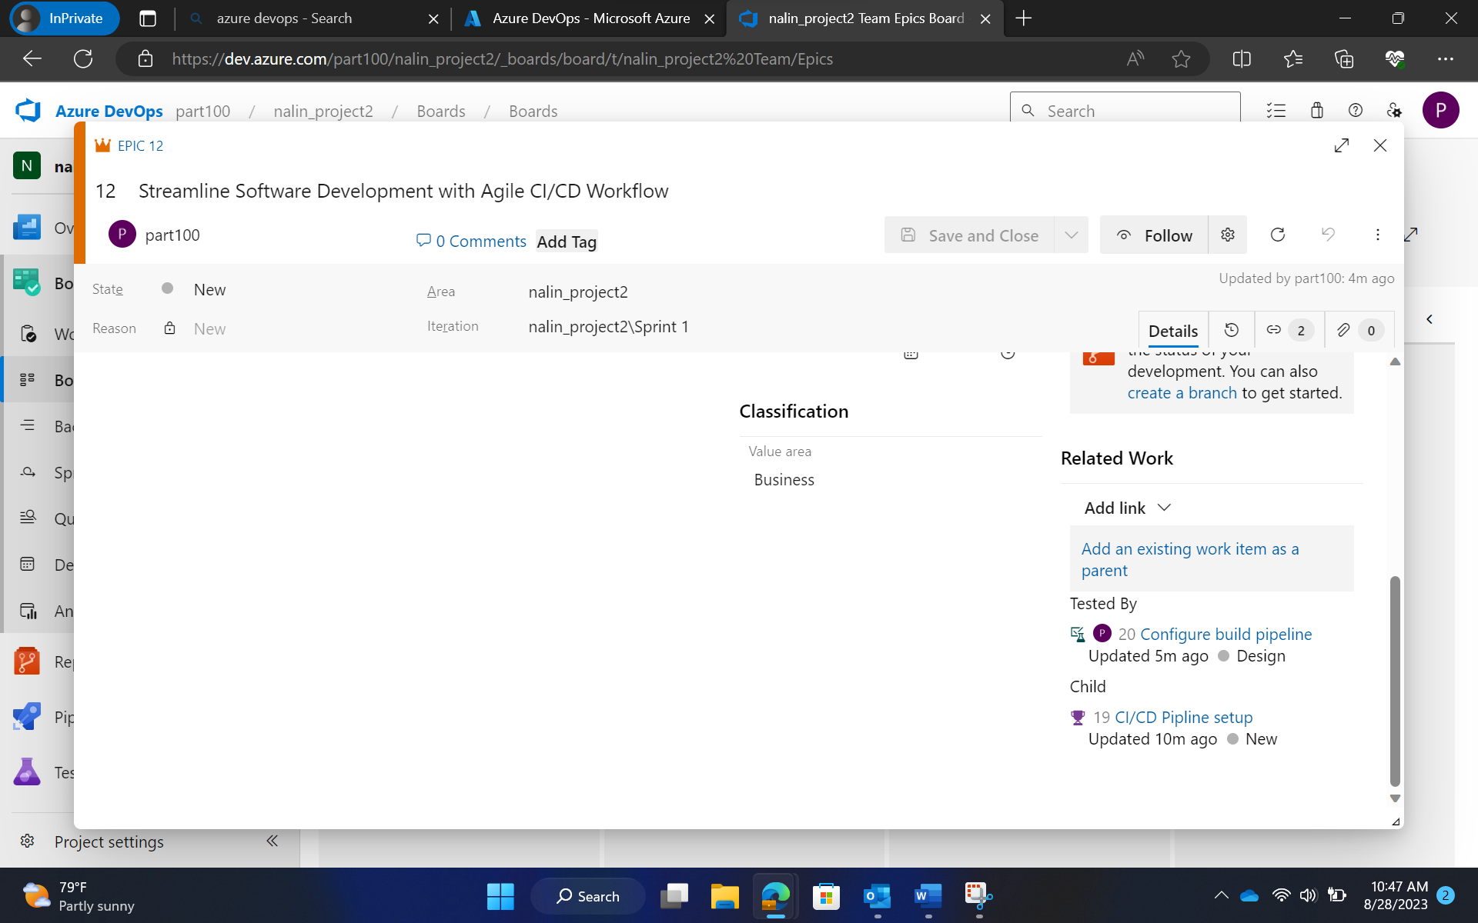

Epic linked with features

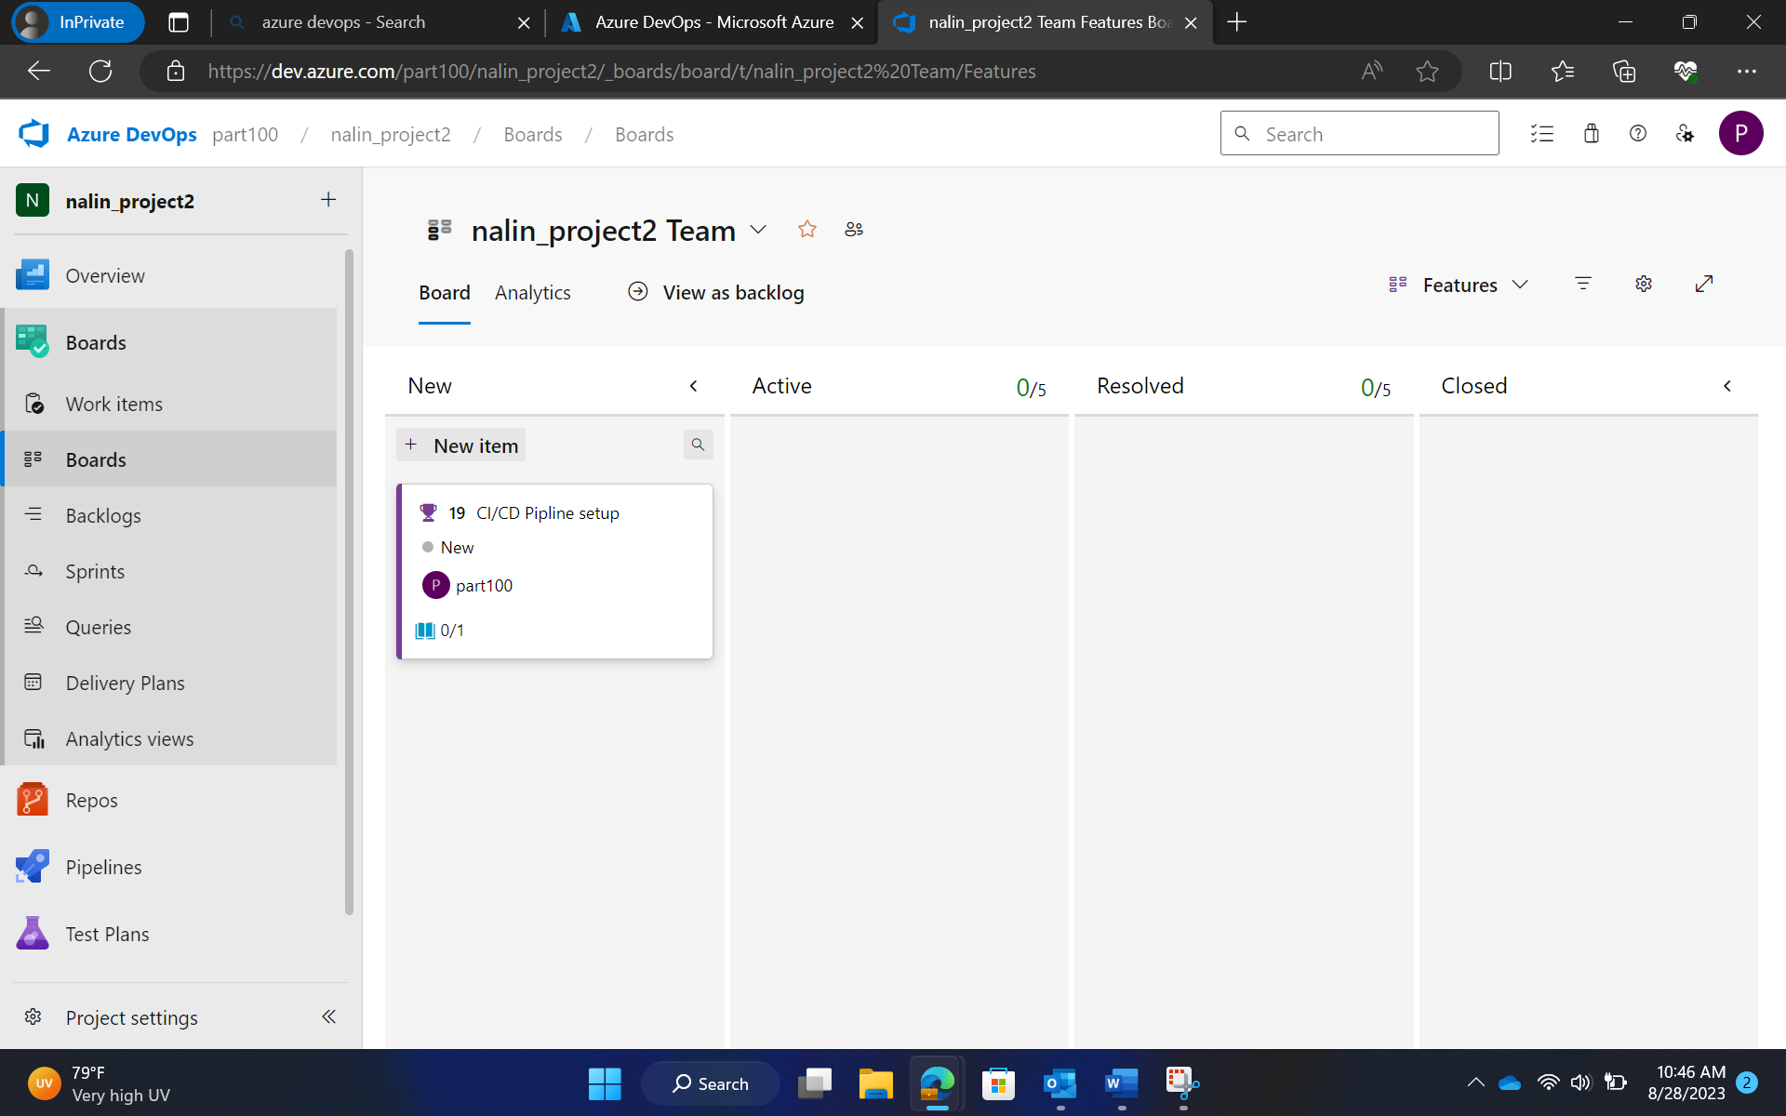

Features

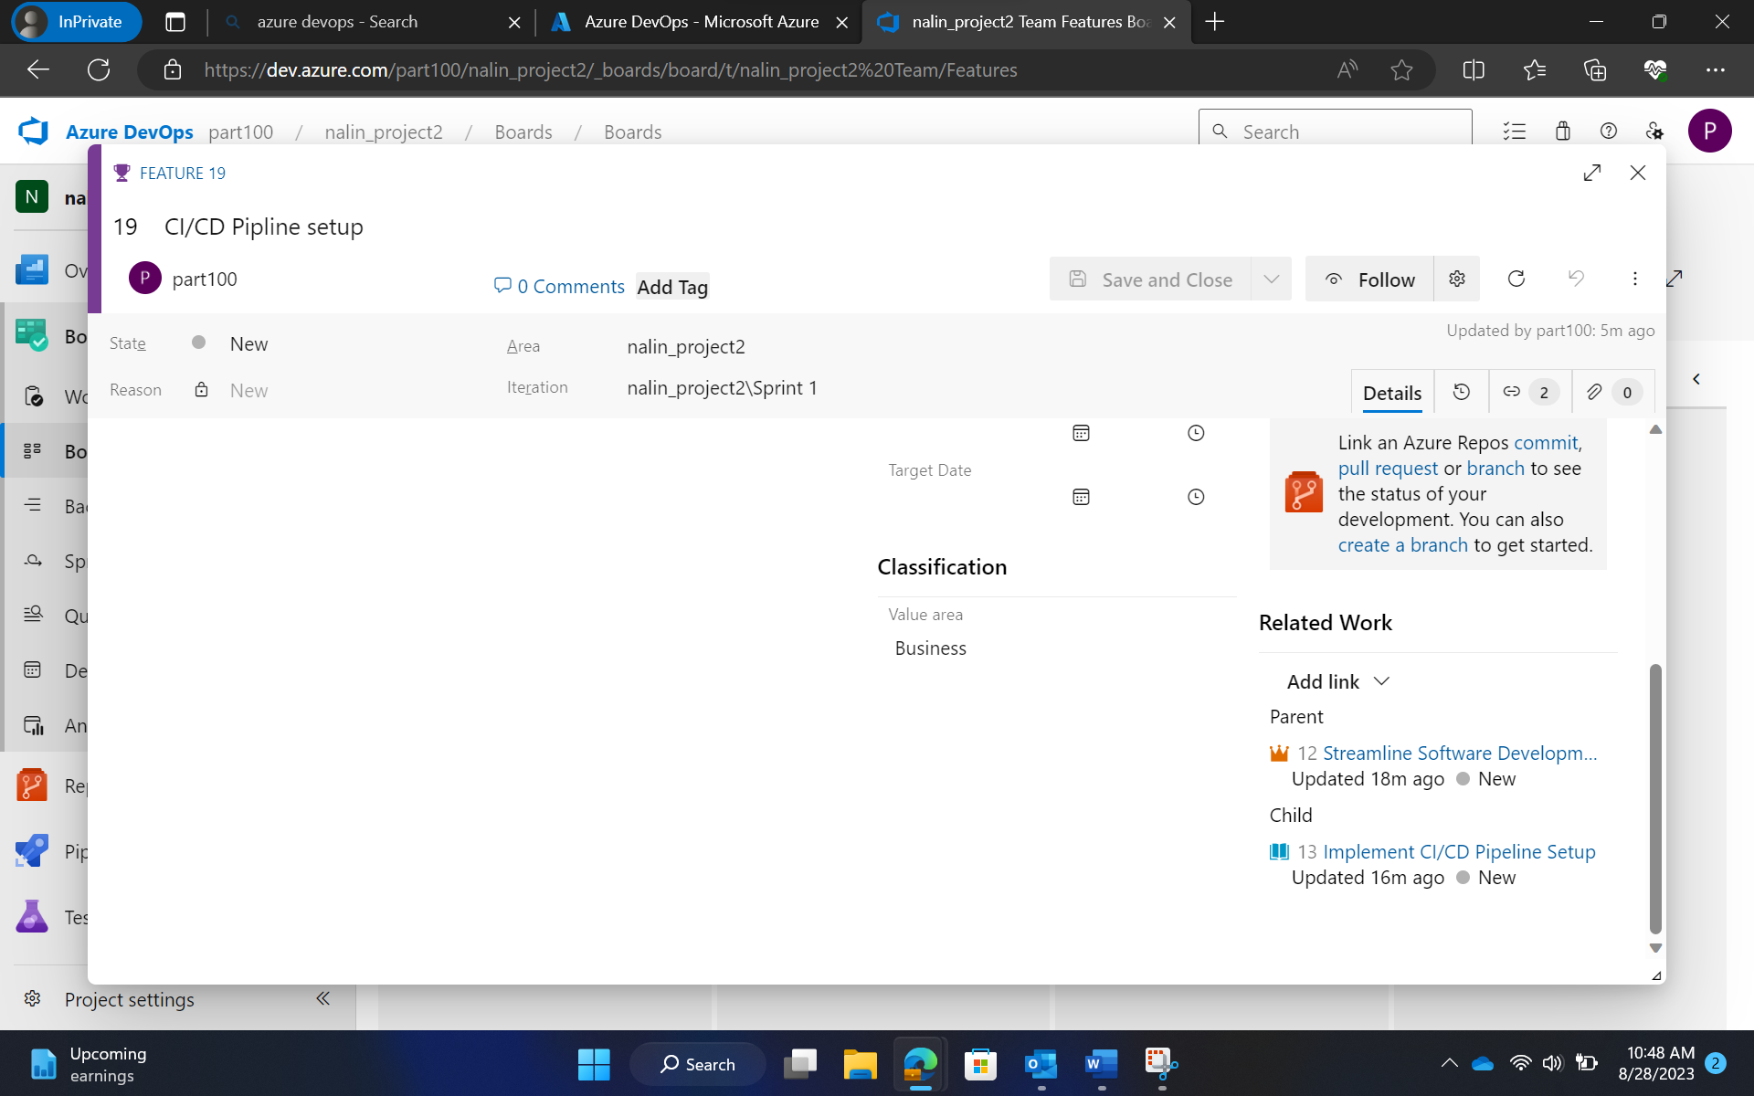

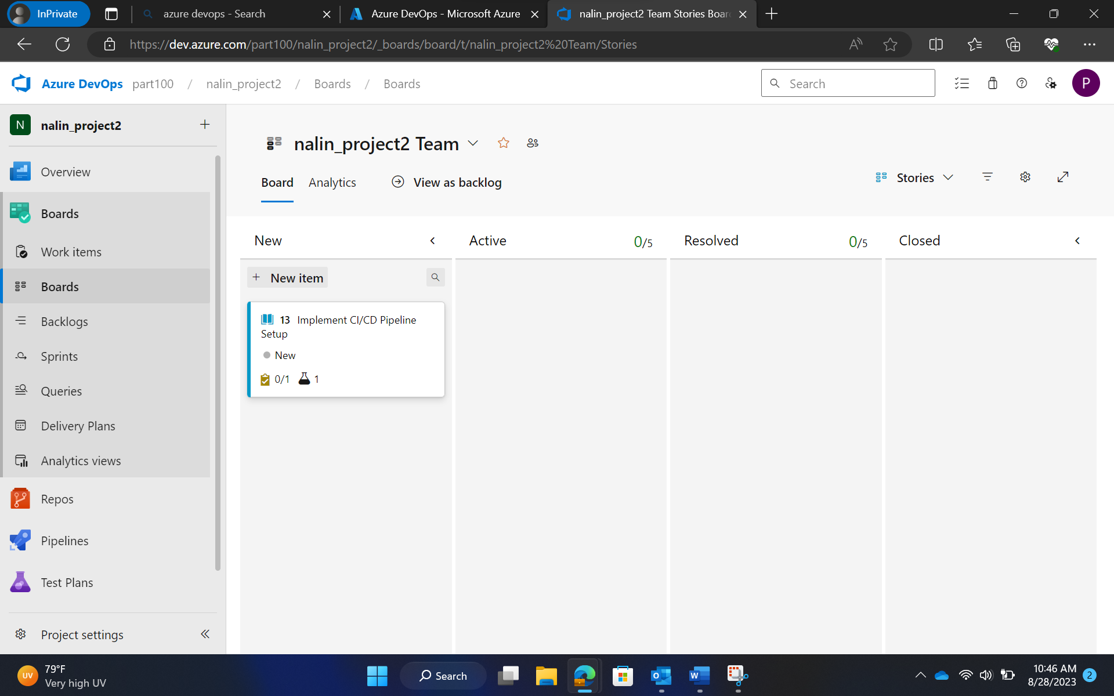

Stories

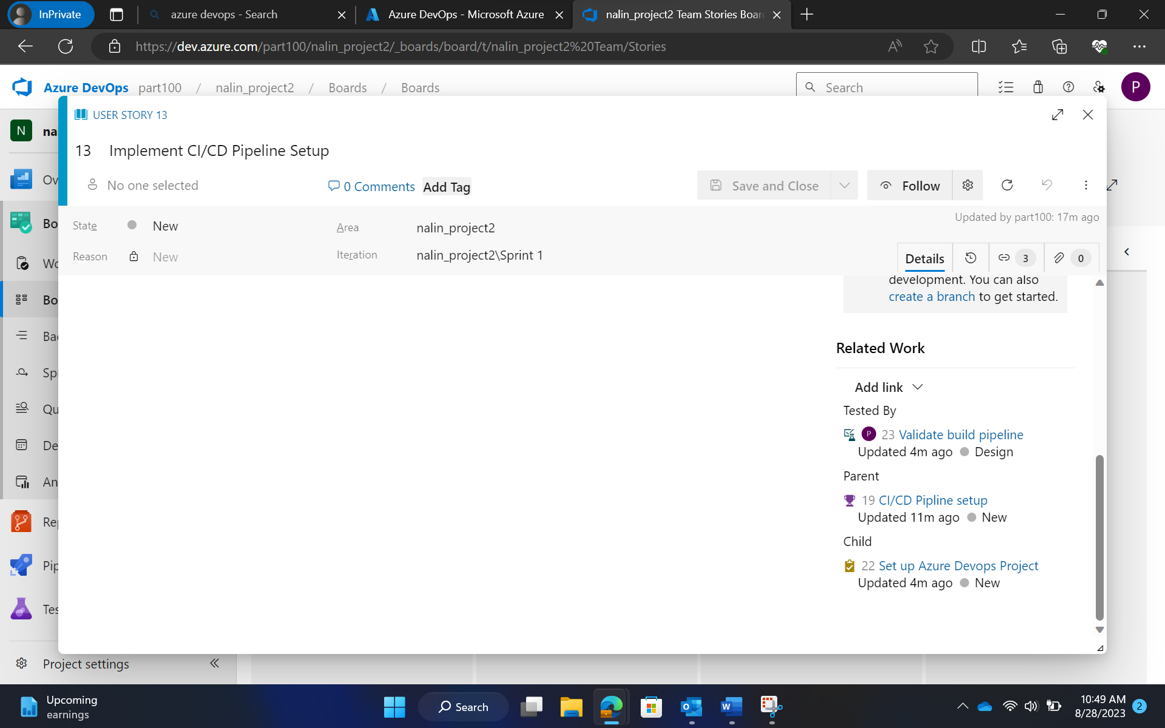

Stories linked with features

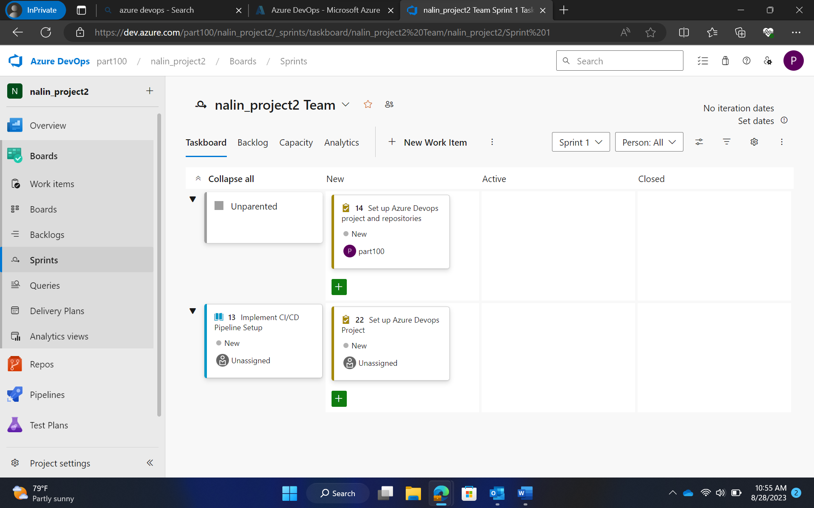

Sprint

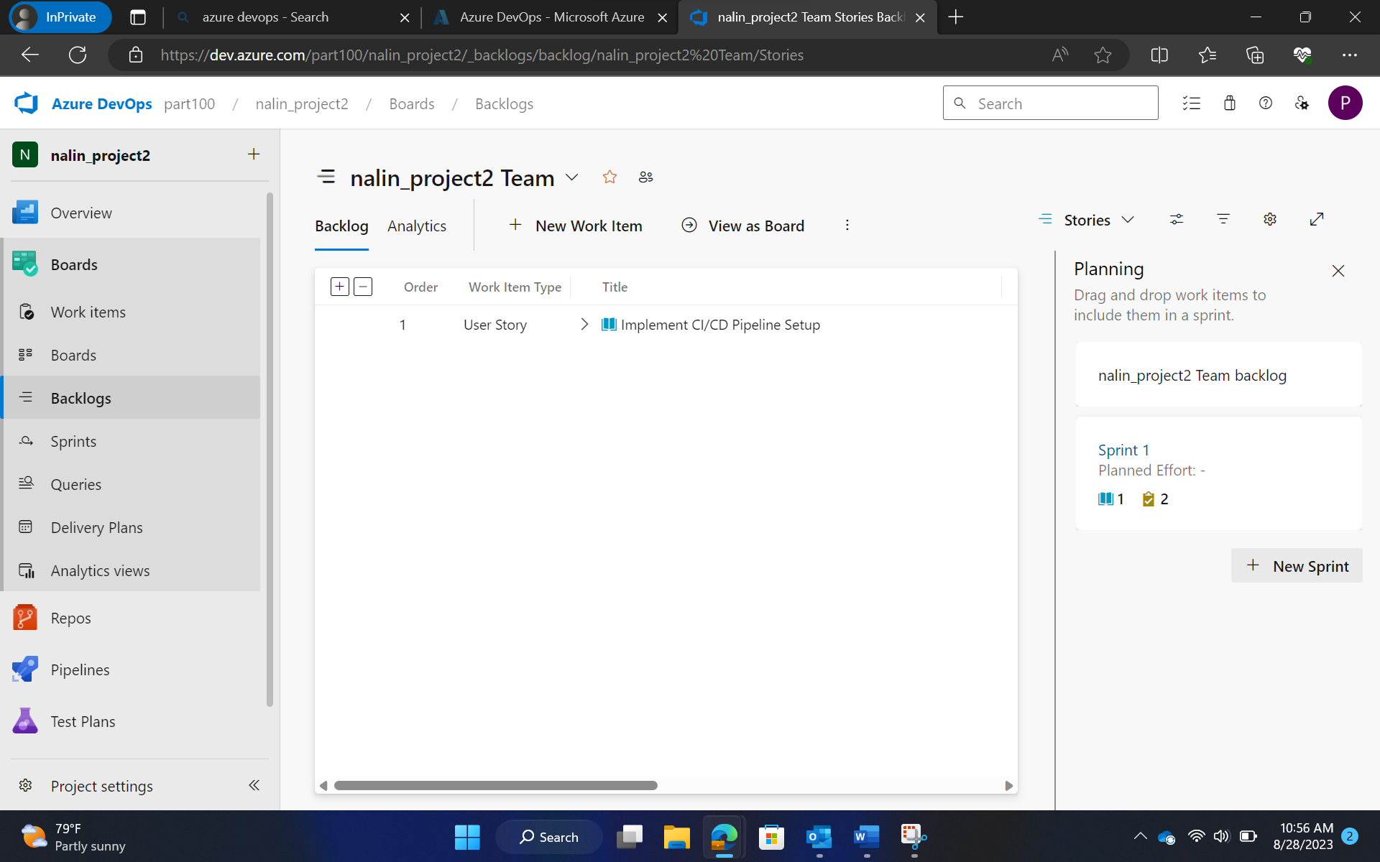

Project Backlog

Step 2: GitHub Repository and Feature Branching

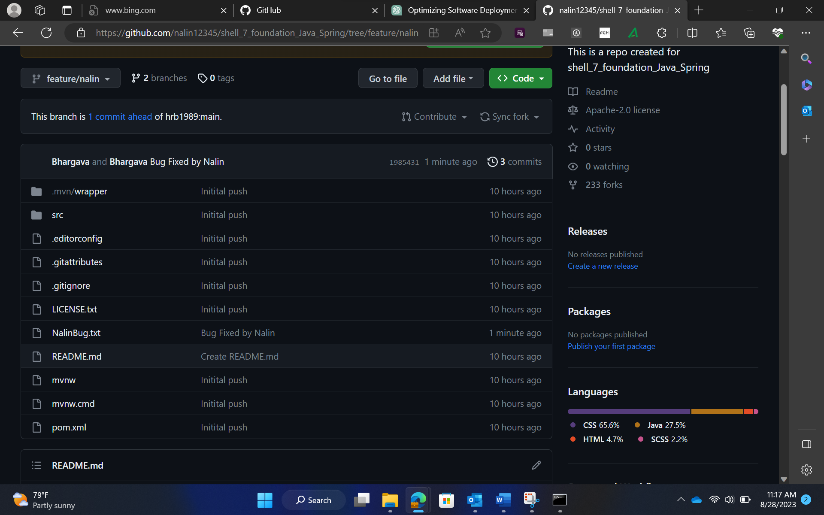

Feature/Nalin branch

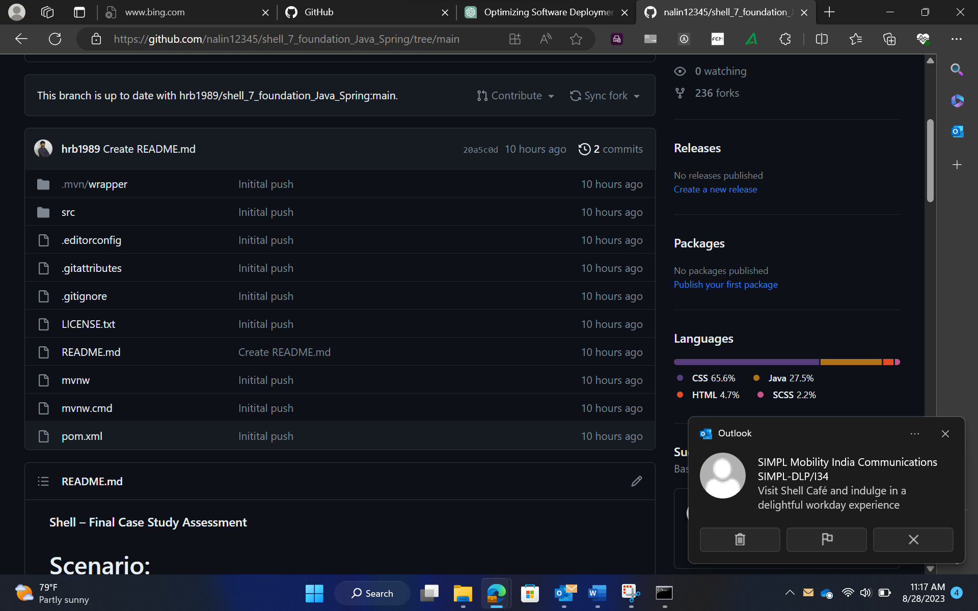

Main branch

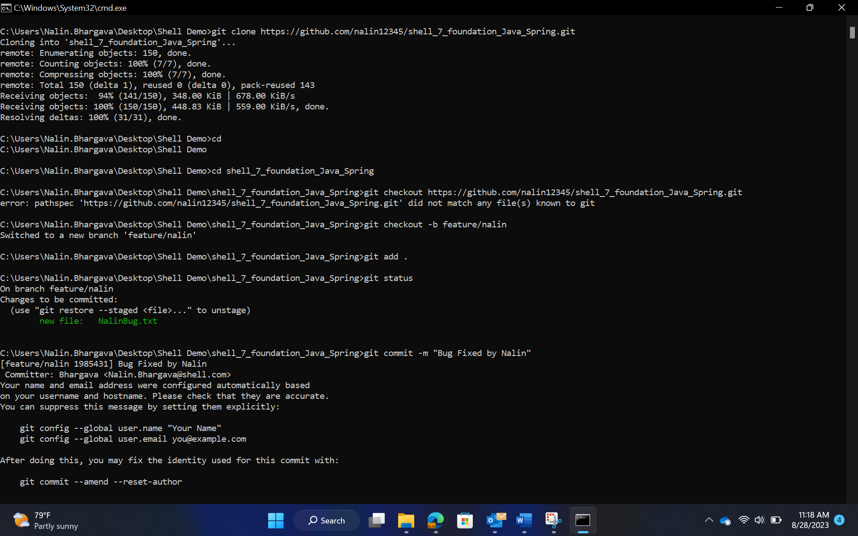

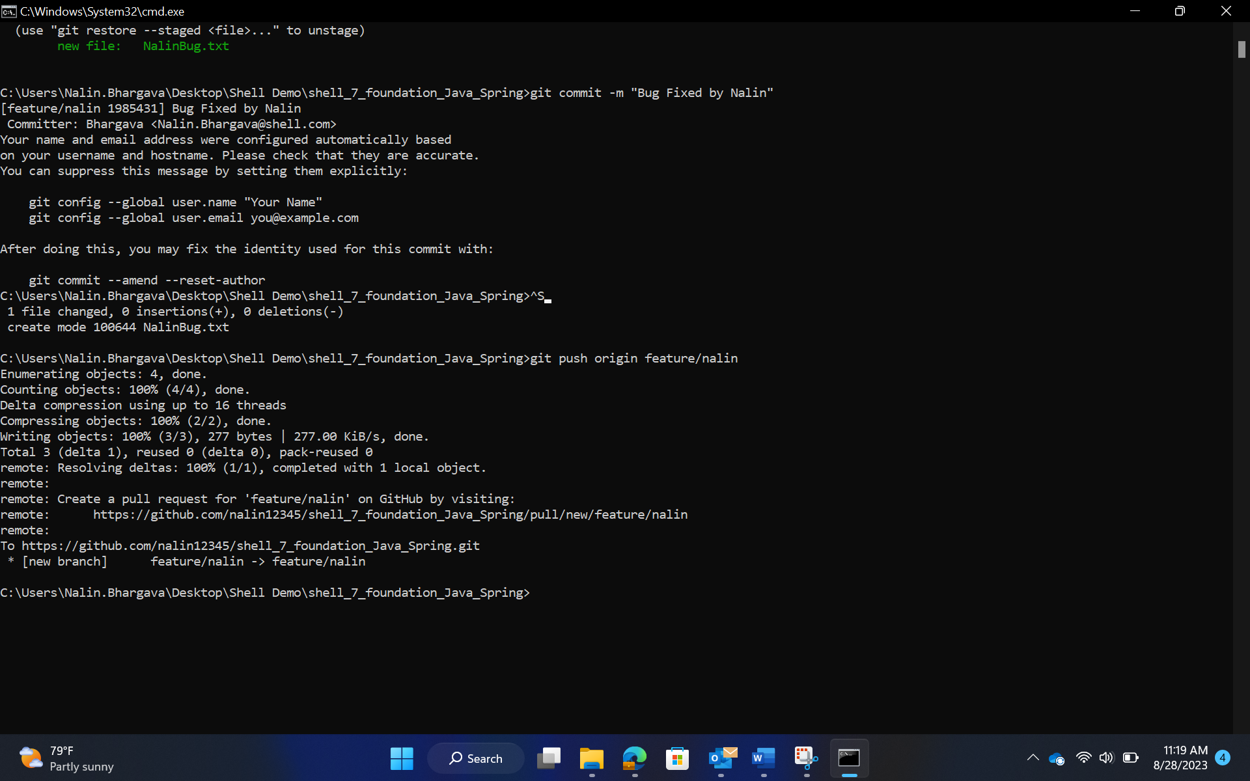

Screenshot of CMD

Step 3: Azure VM Configuration

Create vm

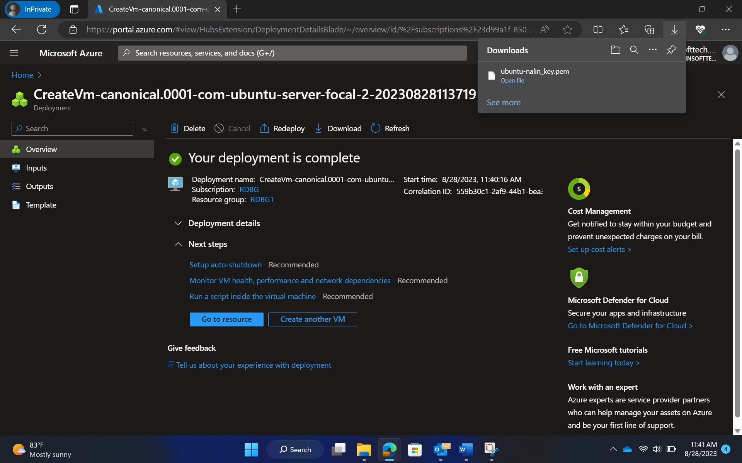

Deployment of VM

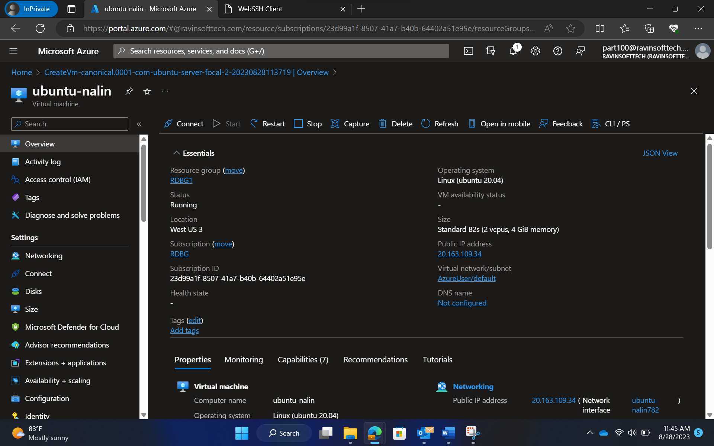

Properties of VM

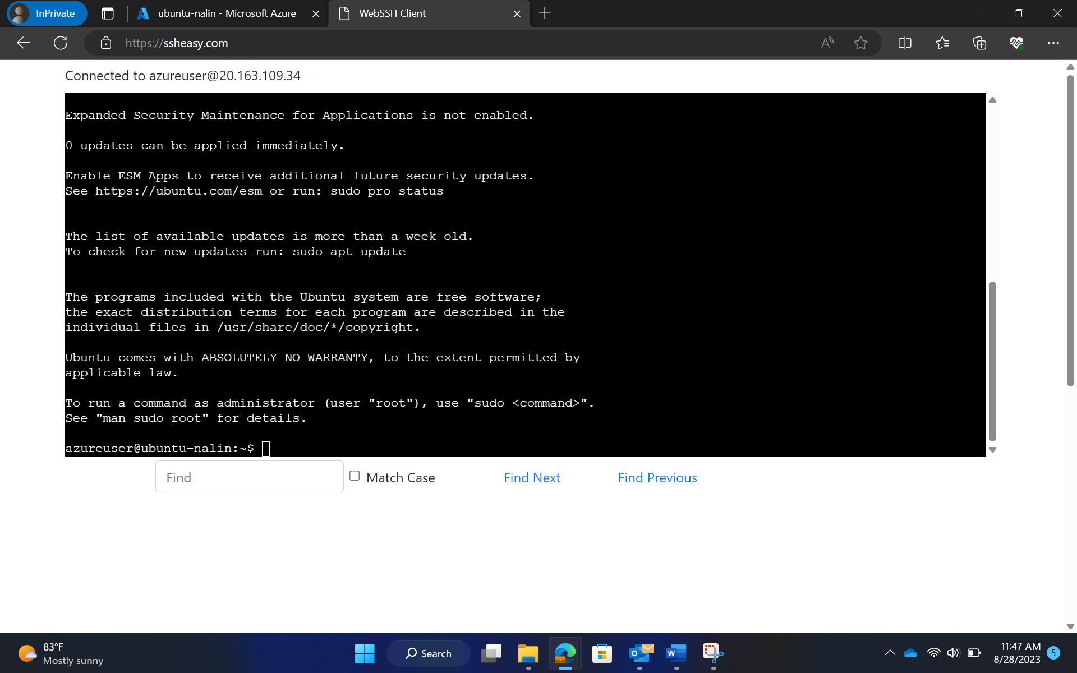

Connection to VM

STEP 4: Maven-Based Build Process:

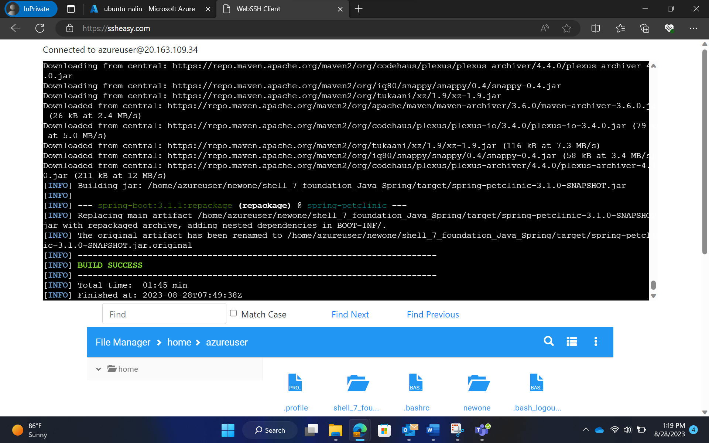

Maven build success

STEP 5 Prometheus Monitoring Integration:

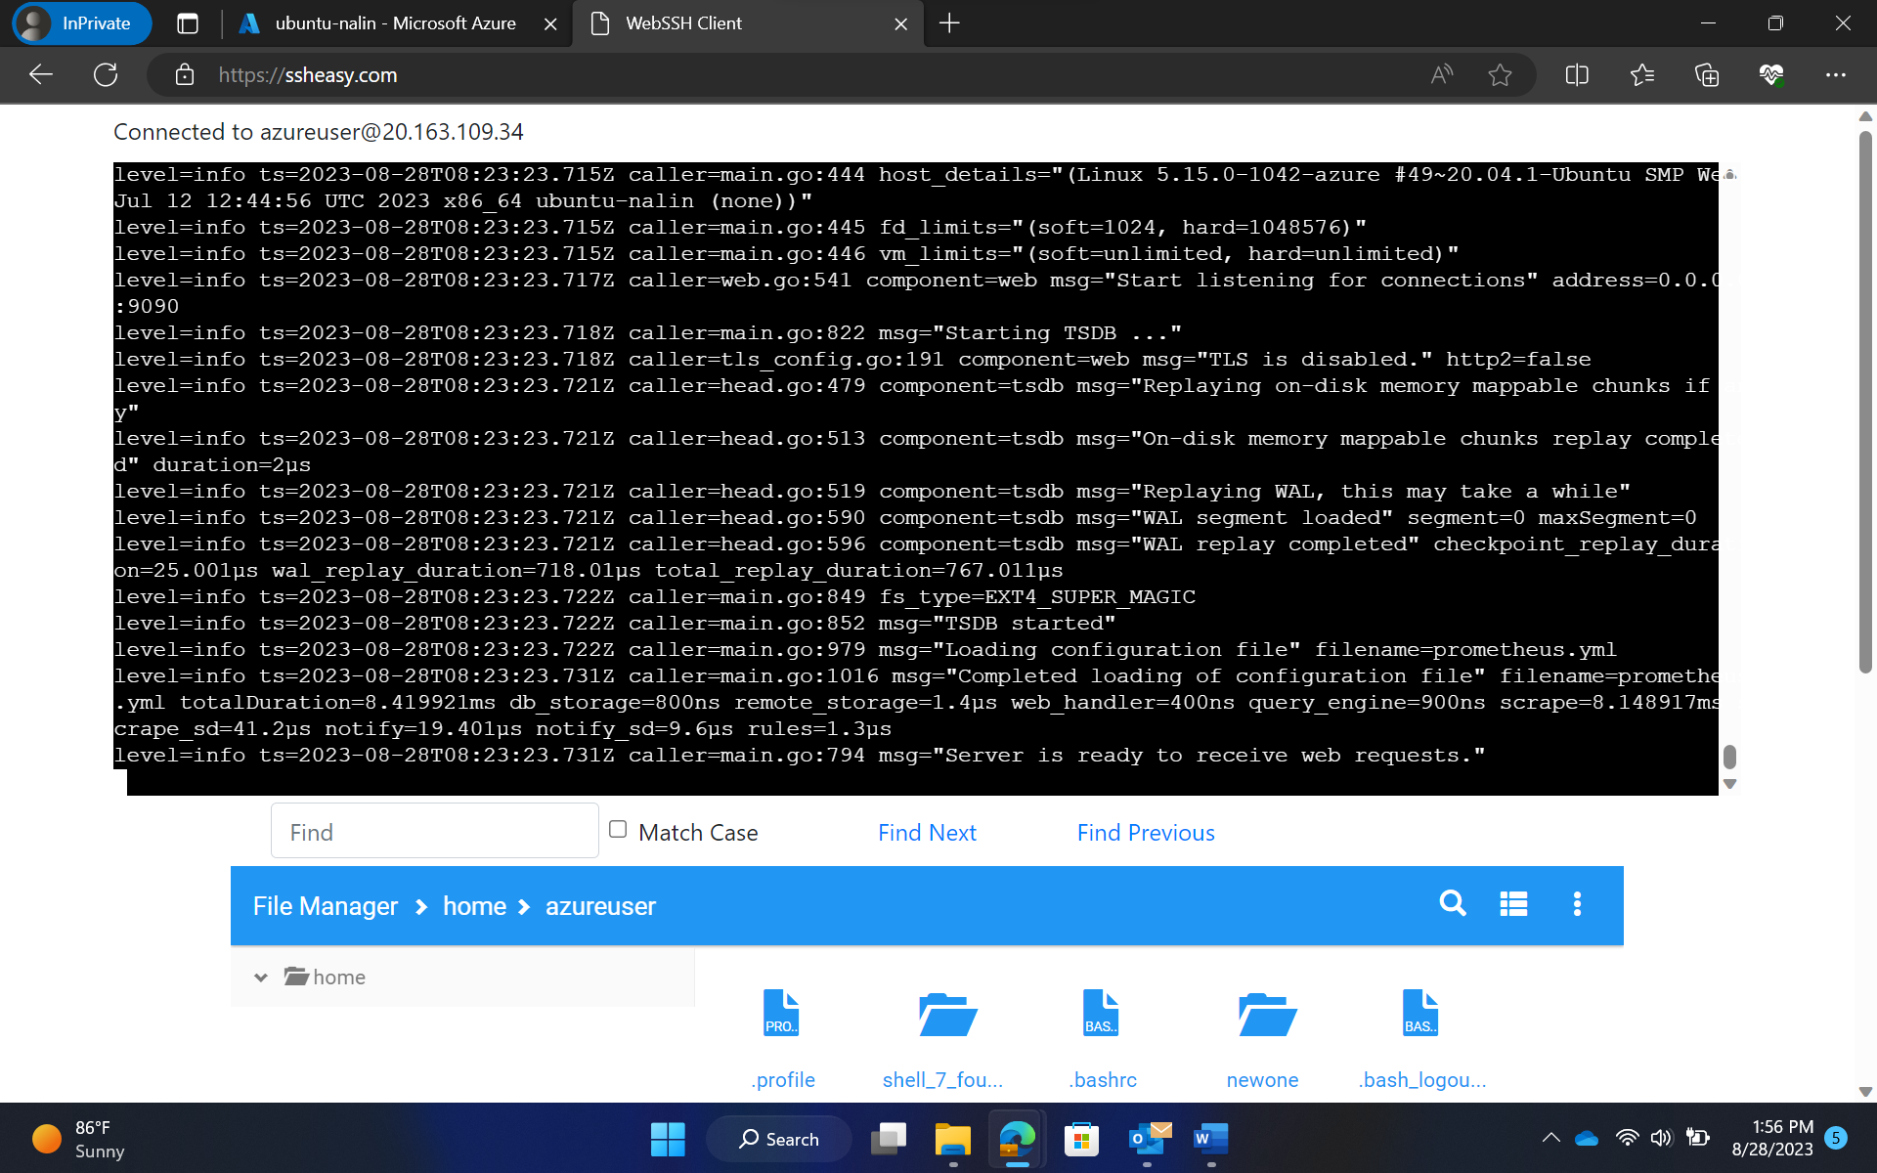

Prometheus running

STEP 6 Docker Containerization:

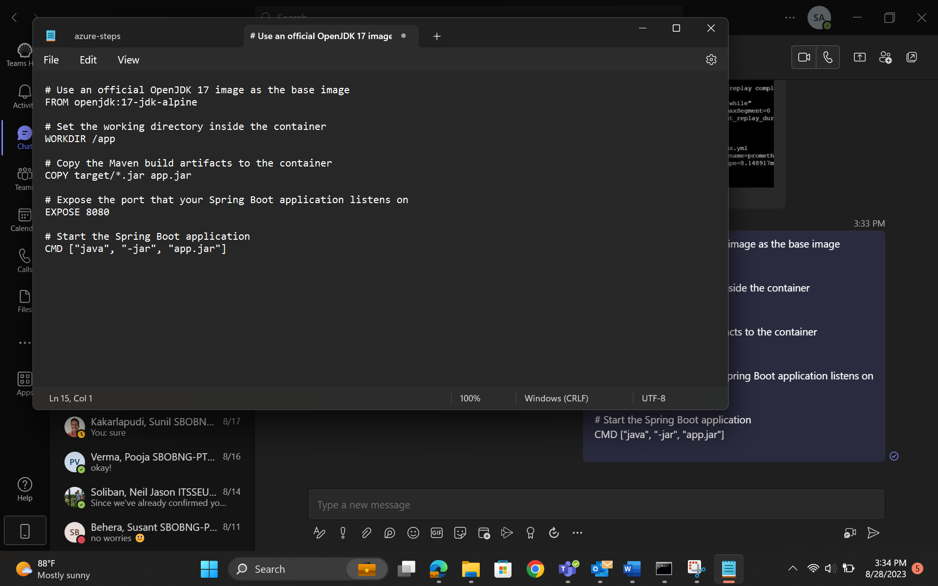

Docker file creation

STEP 7:Azure Web App Configuration

STEP 8: Pull Request Collaboration and GitHub Actions Workflow Implementation

Pull request created

Unable to follow with integration

STEP 9: Local Testing of Azure Web App

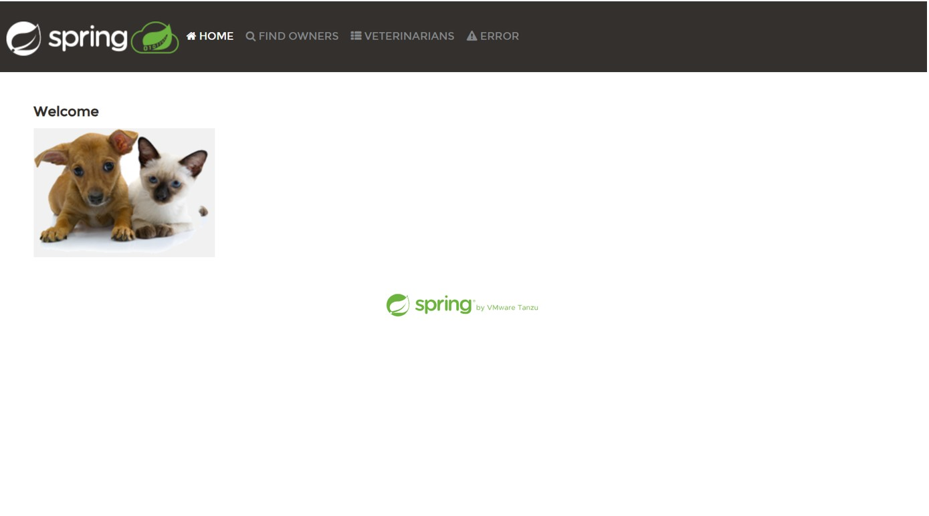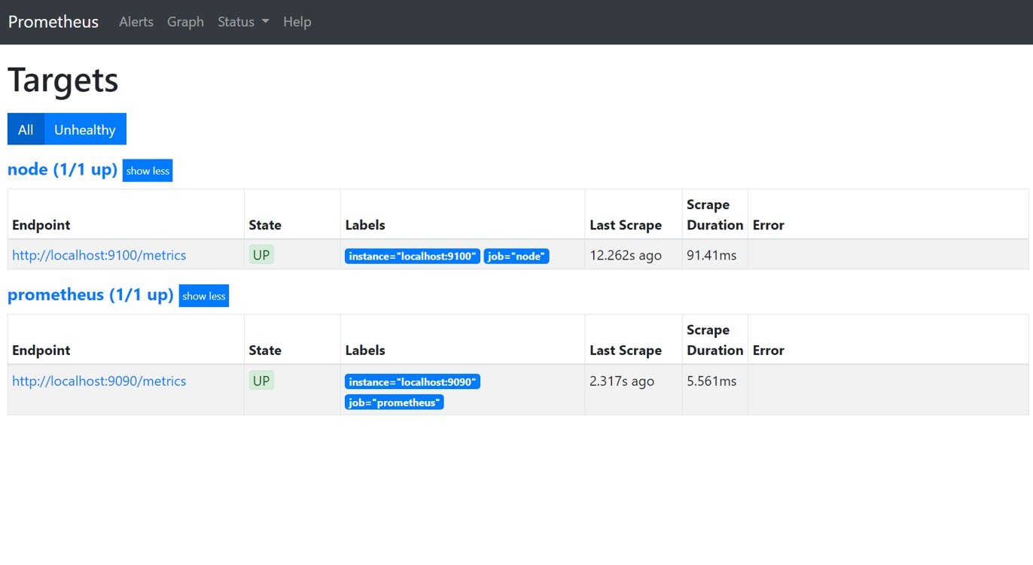

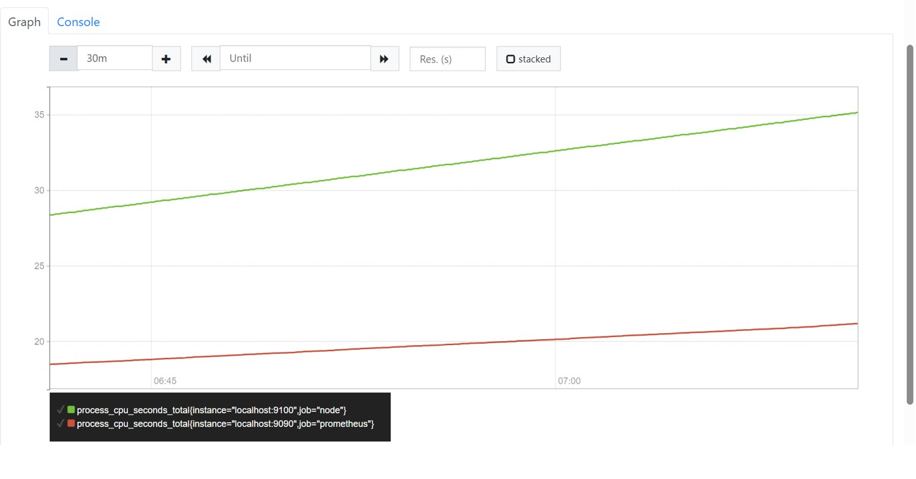

STEP 11: OUTCOME

By meticulously integrating the CI/CD workflow it is strategically positioned to achieve its objective of swift and dependable software deployments for its Java Spring Boot application. This approach ensures that software enhancements and new features can be seamlessly delivered to customers, maintaining a high standard of quality.